Analyze a Dataset Using Tableau

# Task:

Use Tableau to analyze and answer the questions within the data set provided. Please download the dataset from: <https://1drv.ms/u/s!ApedUrEV9Dldvi12wPxhQCMddToy>

**Bonus Marks:**   
You can get 5 bonus points if you do question 6 and 7. Get an additional 5 bonus points if you create a Web Intelligence document to answer any 3 questions. These bonus points will be counted only towards your assignments.

# Deliverable:

1. Create a Tableau packaged workbook (.twbx) based on the Excel data file “Chicago_Crime.csv”
2. Create data visualizations, one for each question listed on the next page. Each visualization should be on a separate worksheet within the workbook and it should provide the answer to the question. Label each worksheet “Question 1,” “Question 2,” and so on.
3. Using the visualization you created in #2, answer each question using the Deliverable Worksheet at the end of this document.
4. You should use each of these chart types at least once: bar chart, word cloud, Tree map, and line graph.

Tips:

* You should try to create graphics for all questions
* Keep in mind principles like good use of colors, legends, scale, and aspect ratio. Don’t be afraid to play around with fonts and colors. Also remember, simplicity is good.
* Make sure you are aware of when to use sums versus averages.

# Submission Guidelines:

You should Rename the Tableau packaged Workbook as <Yourname.Assignment4>. Put the answer sheet and the packaged workbook in a folder and zip it. If you are attempting the Web Intelligence bonus part, then include the Web Intelligence (.wid) file in the .zip file. Remember to save the web intelligence document for ‘all user’.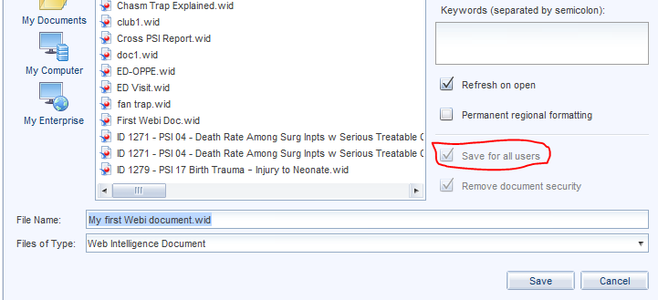

**The answer sheet is on the last page below.**

# Grading:

For each question, your work will be evaluated using the following criteria:

|  |  |  |
| --- | --- | --- |
| Criteria | Weight | Description |
| Answer Provided | 30% | Is the answer to the question correct? |
| Visualization Choice | 30% | Was the correct type graphic chosen to answer the question? |
| Construction | 30% | Is the graphic correctly designed? Are the axes and data points labeled properly? |
| Clarity/Simplicity | 10% | Is the graphic displayed with as little extraneous information as possible while still answering the question? |

# Questions:

***Question 1:***

Which is the most prevalent crime type in quarter two of 2016?  
(Consider Primary Type)

***Question 2:***

Is it safer to be in sidewalk or street in Chicago?

***Question 3:***

Which community area has the highest number of Arrests in each of the year (User should see be able to filter report on year)?

***Question 4:***

Which block recorded the highest number of arrested domestic crimes? Which kind of crime occurred the most in the top five unsafe blocks?

***Question 5:***

Which is the most unsafe Community to be in Chicago? (Hint: Use Community Area)

***Question 6:***

On the Map of Chicago, geotag the several communities, beats and wards. (Hint : Use Latitudes and Longitudes)

***Question 7:***

Create a year over year analysis of Crime Rates.  
(HINT: Use labels!)

***Question 8:***

Compare data from 2015 and 2016 and record the Months with least and highest number of crimes?

***Question 9:***

Compare Christmas day of 2015 and 2016, which hour of the day was safest on Christmas of 2015 and which hour recorded maximum crimes on Christmas of 2016? (Hint: Use a single graph)

**Deliverable Worksheet** **Name : Lokesh Kumar Chaturvedi Lolla**

Use this worksheet to complete the assignment. The questions are above.

|  |  |
| --- | --- |
| Question | Your Answer |
| 1 | Theft |
| 2 | Sidewalk is safe compared to street |
| 3 | Community area which has the highest number of arrests in 2015, 2016 and 2017 is same. Community area: 25 |
| 4 | Block With highest number of arrested domestic crimes: 064XX S DR MARTIN LUTHER KING JR DR,  Most prevalent crime type in top 5 unsafe blocks: Battery |
| 5 | 25 |
| 6 | Visualization showcased in Tableau |
| 7 | Visualization showcased in Tableau |
| 8 | Least number of crimes in the month: February 2015, February 2016  Maximum number of crimes in the month: August 2015, July 2016 |
| 9 | Safest hour (Christmas day) in 2015: 7:00,  Maximum crimes happened in the hour (Christmas day) in 2016: 18:00 and 19:00 |